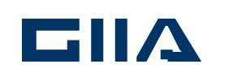

Notice of Meeting

Notice is hereby given that the 2018 Annual General Meeting of the Guernsey International Insurance Association will be held at Moores Hotel, St Peter Port on Tuesday 13th February 2018 at 5.30 pm

AGENDA

- Apologies for absence

- Minutes of the previous AGM

- Matters Arising

- Chairman’s Report

- Treasurer’s report and consideration of the audited accounts

6. Election of Officers and Committee

7. Election of representative to serve on the GIBA Council

8. Appointment of Auditors

9. Any other business

